Name – Shaurya Singh Srinet

Reg No – RA2111032010006

Branch – CSE w/s in IoT

Section – T2

Object Oriented Design and Programming

Assignment: Week 5: -

1. Write a program to print the names of students by creating a Student class. If no name is passed while creating an object of the Student class, then the name should be, otherwise the name should be equal to the String value passed while creating the object of the Student class.

Code: -

#include <iostream>

using namespace std;

class Student

{

public:

Student(string name)

{

cout<<"Your name: "<<name;

}

Student()

{

cout<<"Unknown";

}

};

int main()

{

string s;

cout<<"Enter your name: ";

getline(cin,s);

if(s.empty())

Student st;

else

Student st(s);

return 0;

}

Input and Output: -





2. Suppose you have a Piggie Bank with an initial amount of $50 and you have to add some more amount to it. Create a class AddAmount with a data member named amount with an initial value of $50. Now make two constructors of this class as follows:

1 - without any parameter - no amount will be added to the Piggie Bank

2 - having a parameter which is the amount that will be added to the Piggie Bank

Create an object of the AddAmount class and display the final amount in the PiggieBank.

Code: -

#include <iostream>

using namespace std;

class AddAmount

{

public:

int amount=50;

AddAmount()

{

cout<<"Initial amount in the Piggie Bank: "<<amount<<"$\n";

}

AddAmount(int add)

{

cout<<"Final amount in the Piggie bank: "<<amount+add<<"$\n";

}

};

int main()

{

AddAmount a1;

int add;

cout<<"Enter the amount you want to add in the Piggie Bank: ";

cin>>add;

AddAmount a2(add);

return 0;

}

Input and Output: -

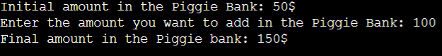

3. Create a class to print the area of a square and a rectangle. The class has two functions with the same name but different number of parameters. The function for printing the area of rectangle has two parameters which are its length and breadth respectively while the other function for printing the area of square has one parameter which is the side of the square.

Code: -

#include <iostream>

using namespace std;

class Area

{

public:

void area(int length, int breadth)

{

cout<<"The area of the rectangle is: "<<length\*breadth<<"m\n\n";

}

void area(int side)

{

cout<<"The area of the square is: "<<side\*side<<"m";

}

};

int main()

{

Area a1;

int r1,r2,s;

cout<<"Enter the length and breadth of the rectangle (in m): -\n";

cin>>r1>>r2;

a1.area(r1,r2);

cout<<"Enter the side of the cube (in m): ";

cin>>s;

a1.area(s);

return 0;

}

Input and Output: -

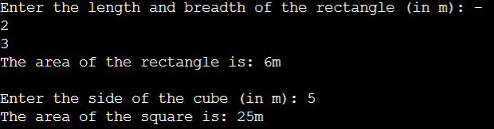

4. A boy has his money deposited $1000, $1500 and $2000 in banks-Bank A, Bank B and Bank C respectively. We have to print the money deposited by him in a particular bank. Create a class Bank with a function getBalance which returns 0. Make its three subclasses named BankA, BankB and BankC with a function with the same name getBalance which returns the amount deposited in that particular bank. Call the function getBalance by the object of each of the three banks.

Code: -

#include <iostream>

using namespace std;

class Bank

{

public:

int BA=1000,BB=1500,BC=2000;

int getBalance()

{

return 0;

}

};

class BankA:public Bank{

public:

int getBalance()

{

return BA;

}

};

class BankB:public Bank{

public:

int getBalance()

{

return BB;

}

};

class BankC:public Bank{

public:

int getBalance()

{

return BC;

}

};

int main()

{

BankA b1;

BankB b2;

BankC b3;

cout<<"Balance in Bank A: "<<b1.getBalance();

cout<<"\nBalance in Bank B: "<<b2.getBalance();

cout<<"\nBalance in Bank C: "<<b3.getBalance();

return 0;

}

Input and Output: -

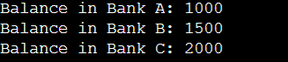

8. Write a C++ program to find Volume of Cube, Cylinder, Sphere using Function Overloading.

Code: -

#include <iostream>

using namespace std;

class Volume

{

public:

void volume(float side)

{

cout<<"The volume of the cube is: "<<side\*side\*side<<"m\n";

}

void volume(float pi, float radius, float height)

{

cout<<"The volume of the cylinder is: "<<pi\*radius\*radius\*height<<"m\n";

}

void volume(float ct, float radius)

{

cout<<"The volume of the sphere is: "<<ct\*radius\*radius\*radius<<"m\n";

}

};

int main()

{

Volume v;

float s,r1,r2,h;

cout<<"Enter the side of the cube (in m): ";

cin>>s;

v.volume(s);

cout<<"Enter the radius and height of the cylinder (in m): -\n";

cin>>r1>>h;

v.volume(3.14,r1,h);

cout<<"Enter the radius of the sphere (in m): ";

cin>>r2;

v.volume(4\*3.14/3,r2);

return 0;

}

Input and Output: -

